Package: - Group of files
Module
Framework
Library
Python Features
Free and Open Source, Object-Oriented Language, GUI programming support, Integrated,
Applications
Software development, Web development, Machine learning artificial intelligence, Desktop GUIs, Web scripting, Data science and visualization
Long Term Support, back to community, Add python to path check,
Comments in python
Single Line Comment #
Multi Line Comment “”
Docs.new:-To write notes
Technical Debt
Variable/identifier Declaration in python
Python is loosely typed Language
Pythons regard all thing as a class and object
Underscore, letter bahek not allowed, use lower case
X=y=z=50; Data types in python Numbers, String. There are three numeric types in python:Int, float, complex
Int
a=10
b=-12
c=12345678
Float
X=1.0
String
S1=’Welcome’
S2=”Welcome”
S3=’’’Welcome’’’
a=4i+2j;Best practices
PR?
Under class that is methods
Otherwise function
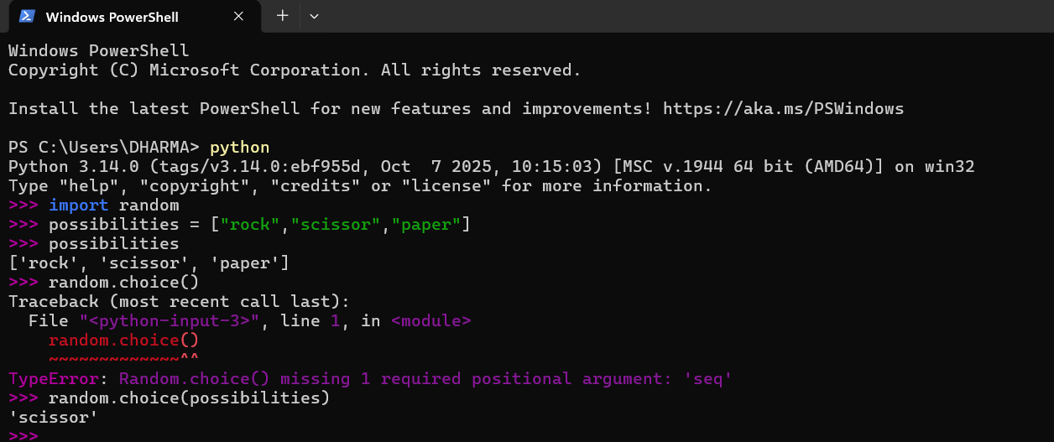
.lower()

